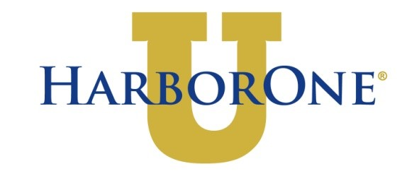

Short Business Plan for SSB Graduates applying for HarborOne $5k Term Loan

Basics

Your Name:

Business Name:

Product or Service Offering:

USP (Unique Selling Proposition - Why am I buying from you?):

Years of Experience in lndustry:

What does your marketing plan look like? (Website, marketing materials, sales plan, etc.)

Competition:
Direct (selling the same product):

lndirect (in your industry):

The Story

Please tell us about your business: Your passion. Your experience.

Business
How do you plan to use the loan funds?
How will this loan help you grow your business?
(List of products or services you will be purchasing. Please include a proposal or cost sheet for products).

Expected Sales for the next 3 months:
Expected Expenses for the next 3 months:
Expected Sales for the next 12 months:
Expected Expenses for the next 12 months:
Quick explanation of how you arrived at these numbers.

Teamwork
Who is on your team? Accountant? Lawyer? Banker? Mentor? MA or RI Small Business Development Center? SCORE?

